[](https://www.myperfectresume.com/membership/RegisterGuestUser.aspx?wizard=true&productid=17&utm_source=hloom-com&utm_medium=referral&utm_campaign=word-template)

**PHP Project**

[eBook]

Full Project



**Table of Content**

* PHP-Project
* Introduction To………………………………………………………3
* Project Duration …………………………………………...........5
* Task Sheet……………………………………………………………6
* Site Map……………………………………………………………….7
* Screen Shots…………………………………………………………9

INTRODUCTION TO

**“**eBook**”**

PROBLEM STATEMENT:

Our client is a famous publisher who publishes books of different categories like comics, novels, story books, General knowledge books, quiz books, journals, etc….. As there is no end for knowledge, which keeps on changing from day to day, the books are needed to be revised for every now and then. As well the stories which keep on coming as there are several writers in the world.

Requirement Specification:

* A database should be created that holds the details of the books, orders, and that of the customers.
* The details of the books are needed to be captured in detail.
* Also the admin (publisher or manager of the publication) can alone have the rights to enter the details of the books like price (either free of cost or some value…), shipment or delivery charges and as well the subscription charges and their brief description.
* The details of the books and as well the details of the customers and the delivery details, shipment details and as well the details of the orders placed are needed to be stored in the database.
* Advanced search option is needed to be included so that the customer can fetch the details.
* The customers should also be able to register with the site.
* On the home page the details of the new releases and the ones that are sold at a very high rate are needed to be mentioned.
* The information about the books will only be accessed by the registered users.
* As soon as the request of an order is placed, the customer should be informed with the details of the order.
* The orders are needed to be easily tracked down by the user.
* The customer who has requested for a book in PDF format then he/she can only be able to access that document only after his/her 1 year registration validity has been verified.
* The Admin solely should have the rights of uploading the details of the books and as well uploading the books in the PDF document form.

Hardware/ Software Requirements

Hardware

* A minimum computer system that will help you access all the tools in the courses is a Pentium 166 or better
* 64 Megabytes of RAM or better

Software

* Adobe Dreamweaver CS6
* Xampp Control Panel

PROJECT DURATION

* Analysis – 5 Days.
* Design – 8 Days.
* Development –12 Days
* Testing – 3 Days.
* Documentation – 2 Days.

|  |  |  |  |  |
| --- | --- | --- | --- | --- |
| Analysis | Design | Development | Testing | Documentation |

|  |  |  |  |  |  |  |  |  |  |  |  |  |  |  |  |  |  |  |  |  |  |  |  |  |  |  |  |  |  |
| --- | --- | --- | --- | --- | --- | --- | --- | --- | --- | --- | --- | --- | --- | --- | --- | --- | --- | --- | --- | --- | --- | --- | --- | --- | --- | --- | --- | --- | --- |
| 1 | 2 | 3 | 4 | 5 | 6 | 7 | 8 | 9 | 10 | 11 | 12 | 13 | 14 | 15 | 16 | 17 | 18 | 19 | 20 | 21 | 22 | 23 | 24 | 25 | 26 | 27 | 28 | 29 | 30 |

TASK SHEET

|  |  |  |  |  |  |
| --- | --- | --- | --- | --- | --- |
| **No.** | **Task** | **Actual Start Date** | **Actual Days** | **Team Mate Name** | **Status** |
| 1. | Case Study | 26th Nov 2018 | 5 | Wasiq  Haseeb  Danish | Completed |
| 2. | Site Interface Designing | 1st Dec 2018 | 8 | Wasiq  Haseeb  Danish | Completed |
| 3. | Development | 9th Dec 2018 | 12 | Wasiq  Haseeb  Danish | Completed |
| 4. | Site Testing/Publishing | 20th Dec 2018 | 3 | Wasiq  Haseeb  Danish | Completed |
| 5. | Documentation | 23th Sep 2018 | 2 | Wasiq  Haseeb  Danish | Completed |

Site Map

Admin Panel

**eBook**

**Dashboard**

**Show Records**

**Add Category**

**Add Author**

**Add Book**

**BBKKK**

**Add Banner**

**Book**

**New Registration**

**Add Publisher**

**Employee**

**Author**

**Order**

**Publisher**

**Category**

**Order Detail**

**Customer**

Front End

**eBook**

**Login**

**Contact Us**

**Cart**

**Faqs**

**Book**

**Category**

**HOME**

**Novel**

**Quiz**

**Story Book**

Screen Shots

Admin Panel

1. 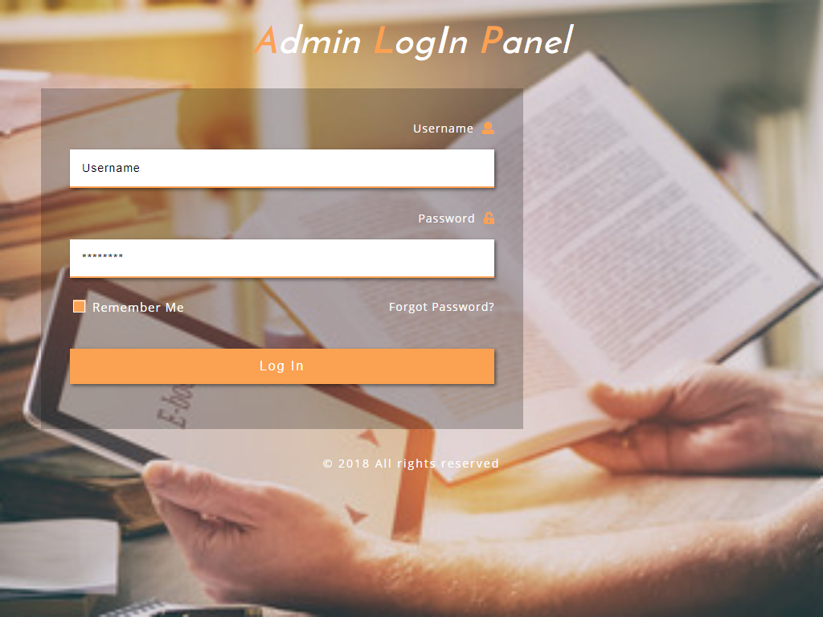Admin Login
2. 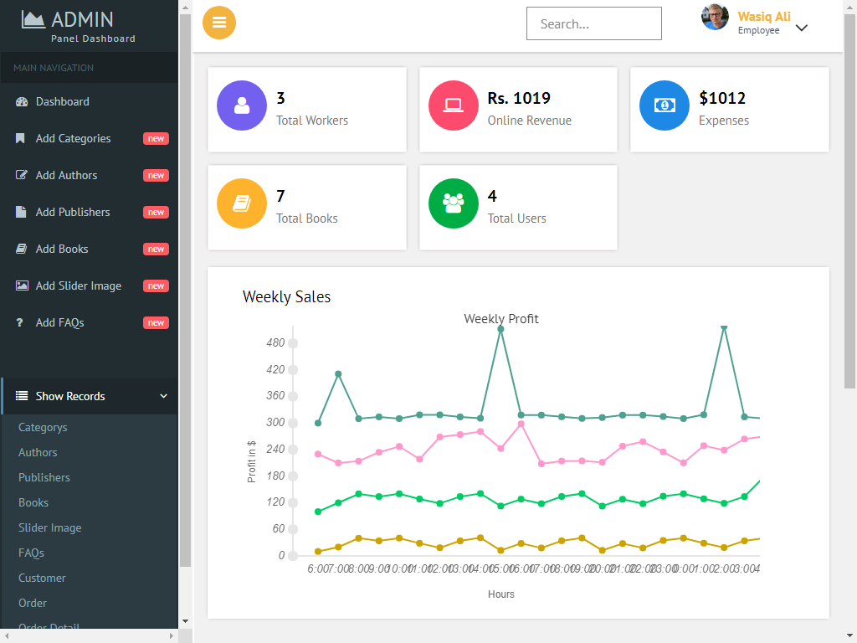Dashboard
3. Registration

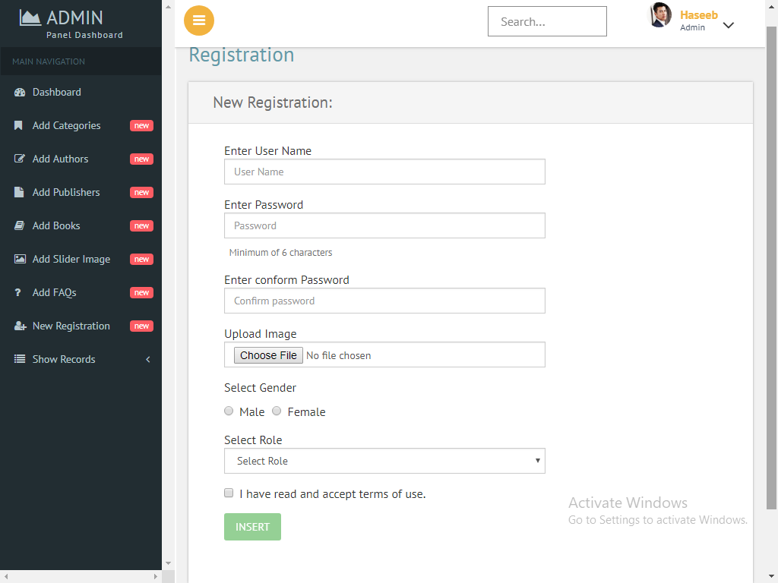

1. 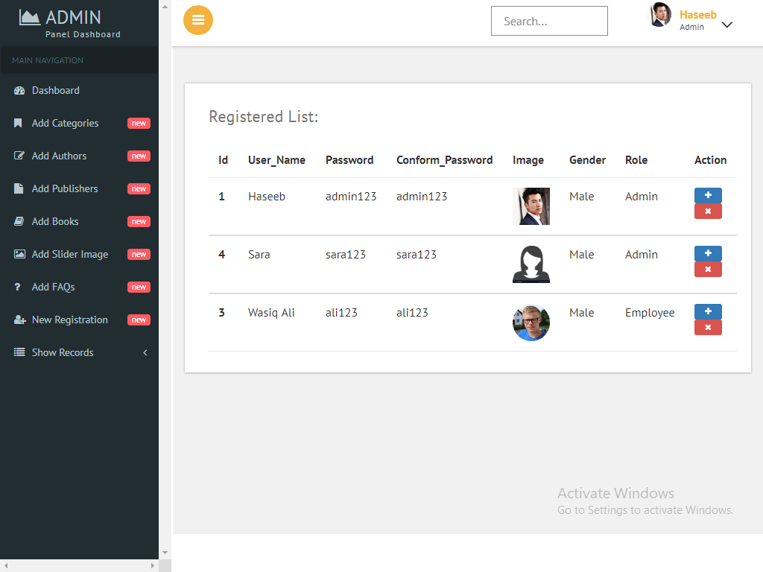Show Employee

1. Add Category

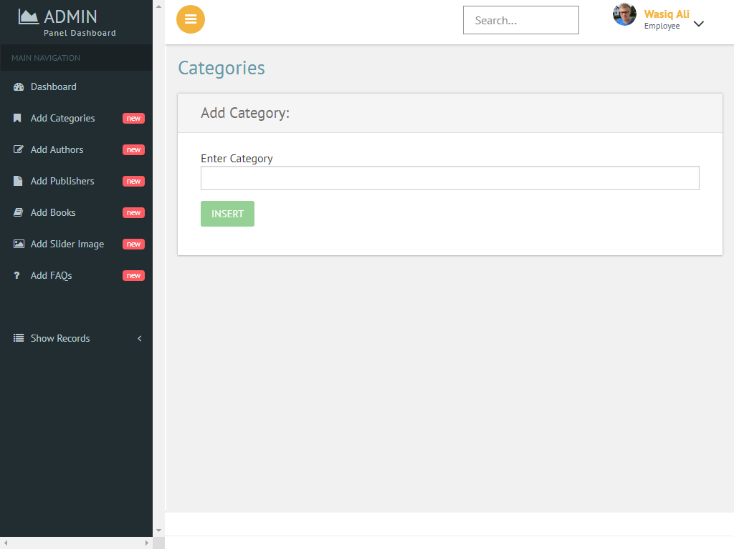

1. Show Category

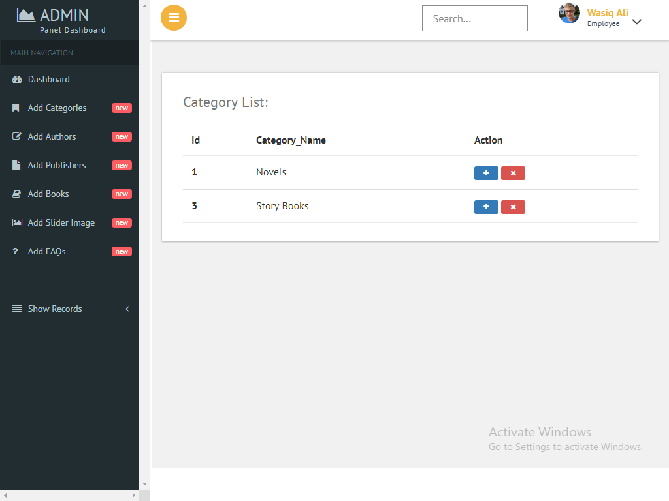

1. Author

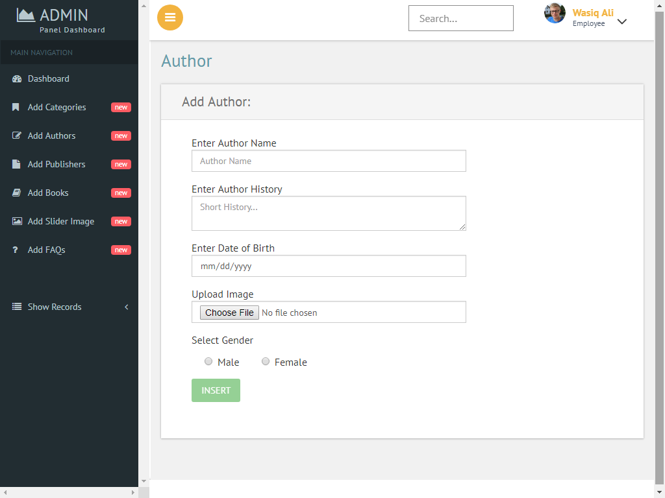

1. Show Author

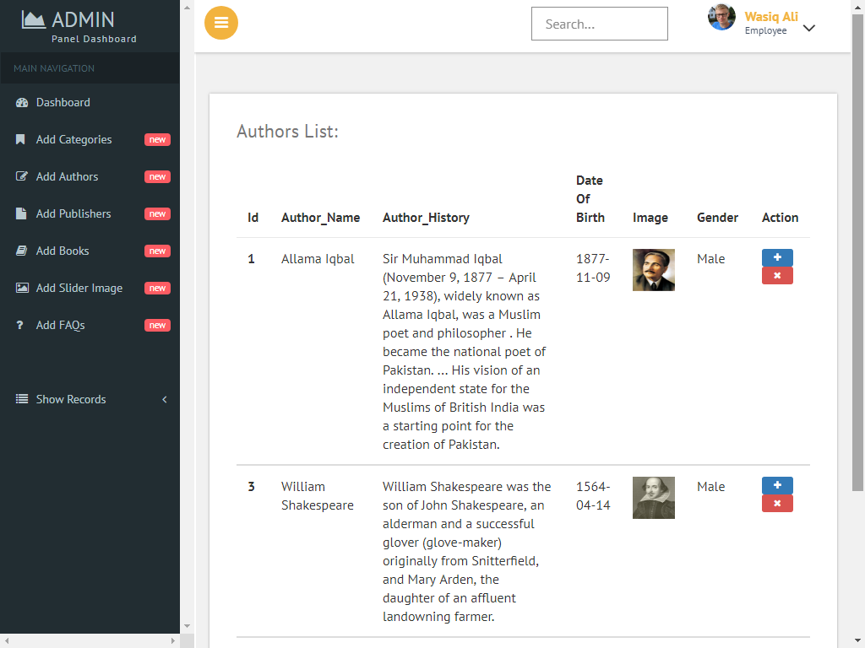

1. Publisher

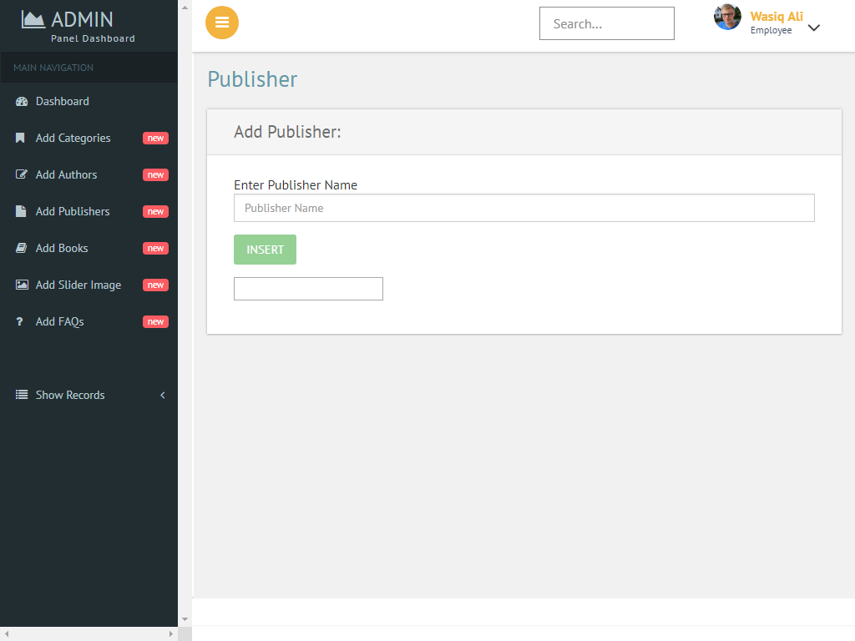

1. Add Book

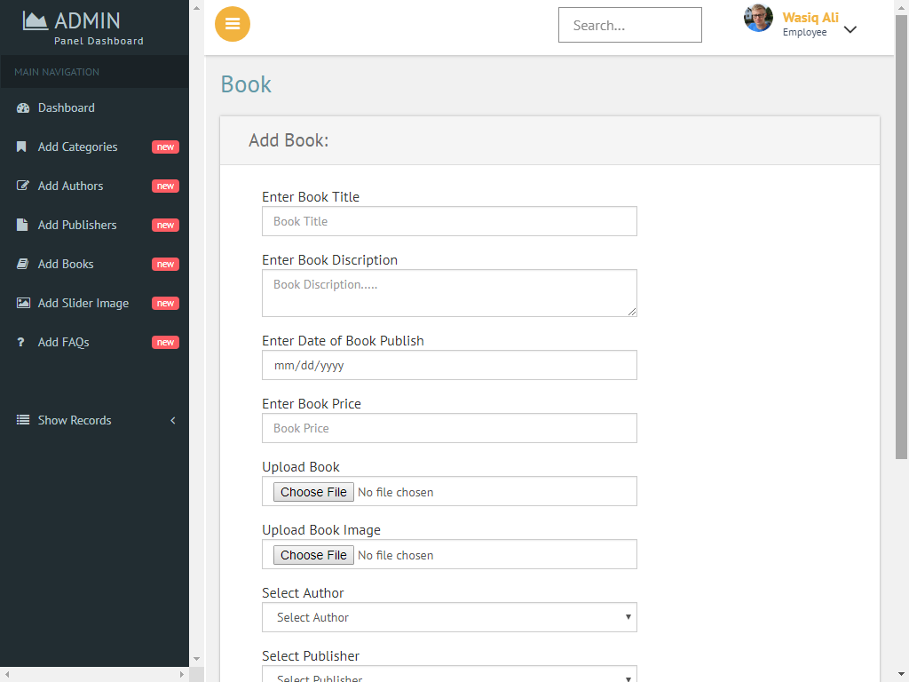

Frontend

1. Index



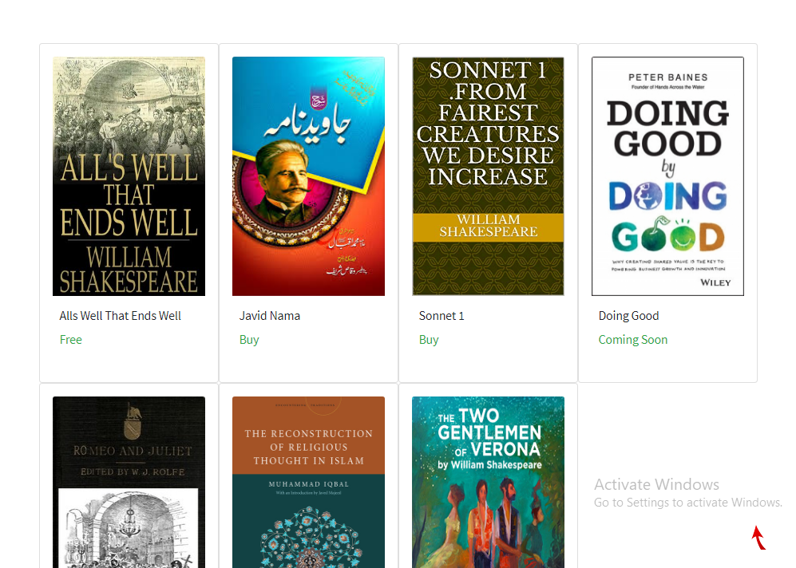



1. Category wise Book

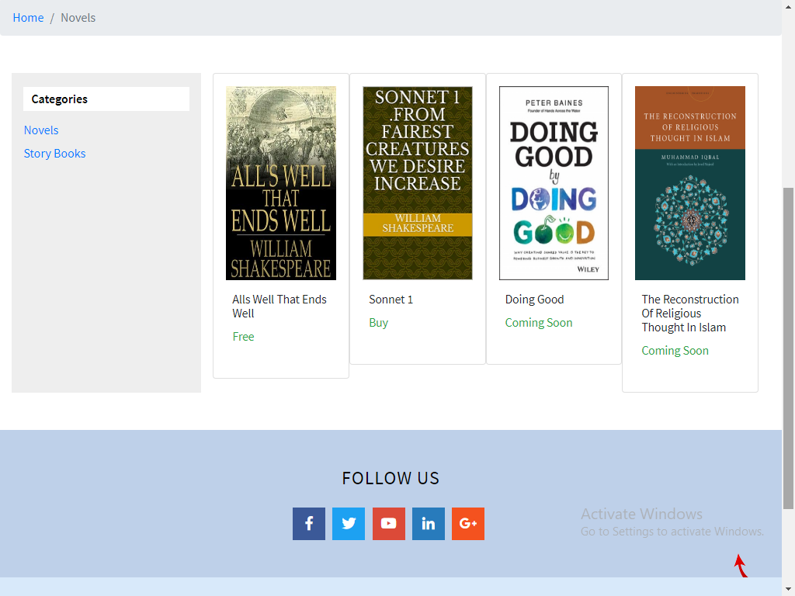

1. Single Book

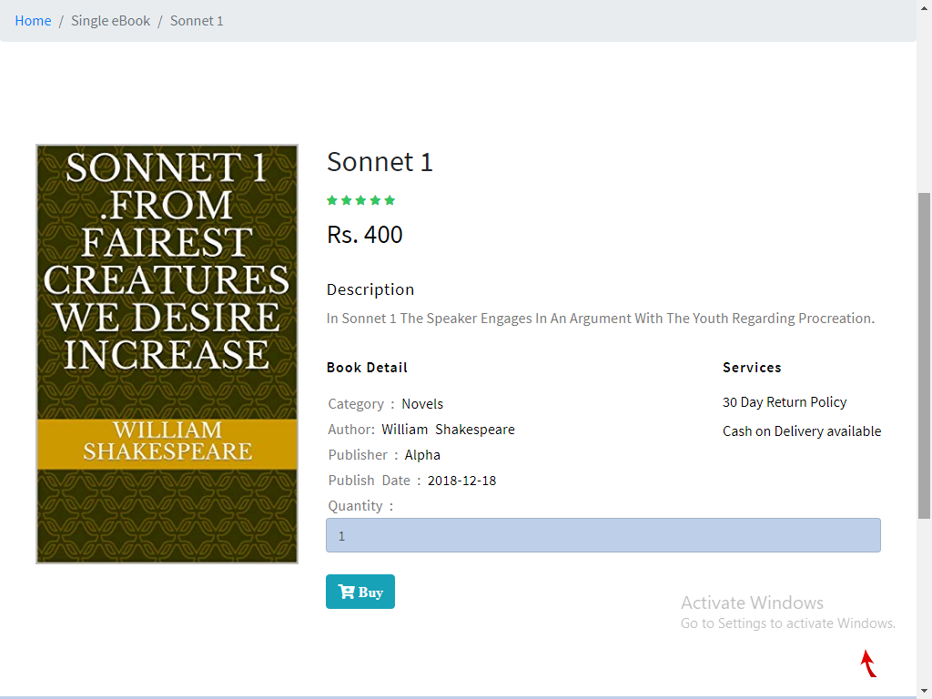

1. Cart

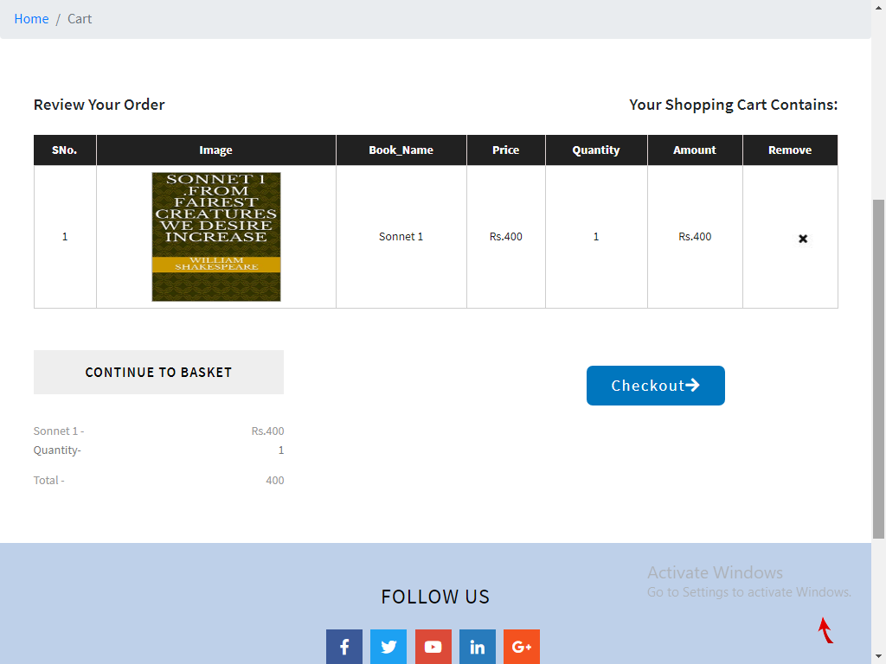

1. Customer Registration

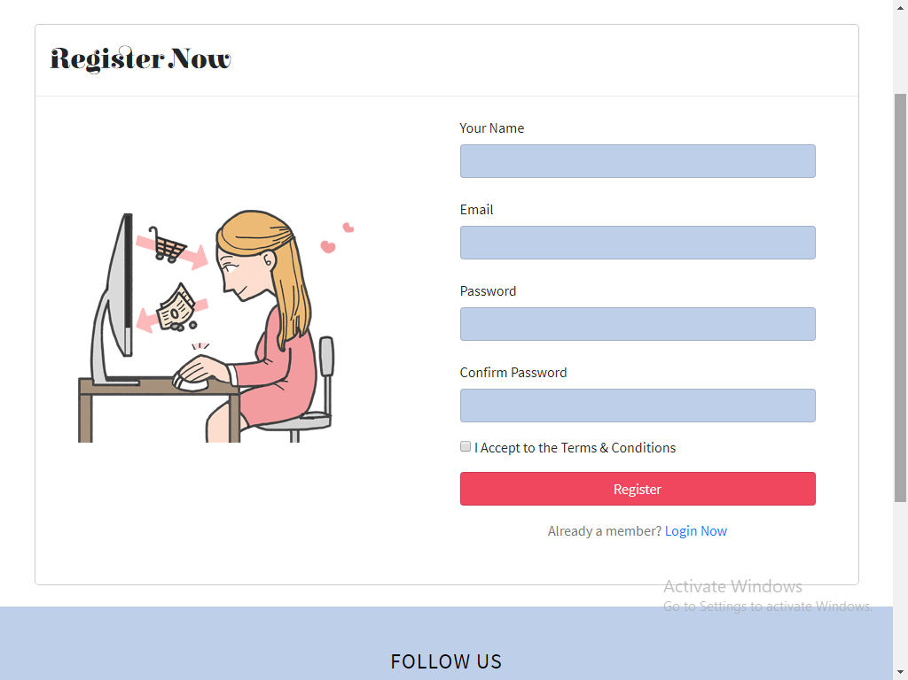

1. Customer Login

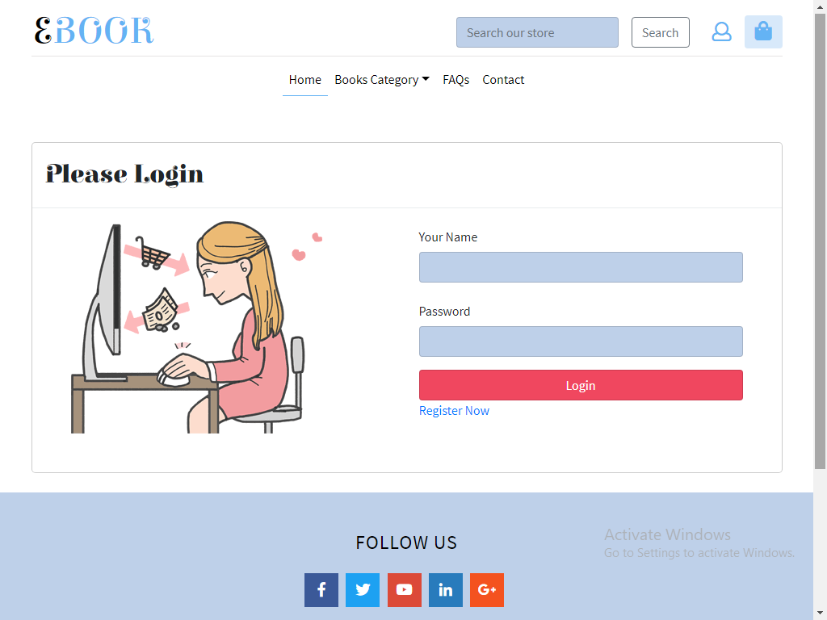

1. Checkout

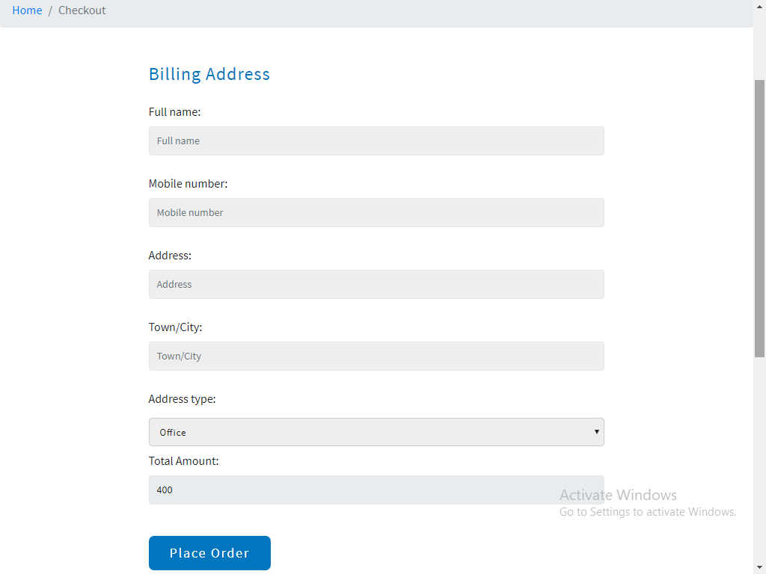

1. Payment

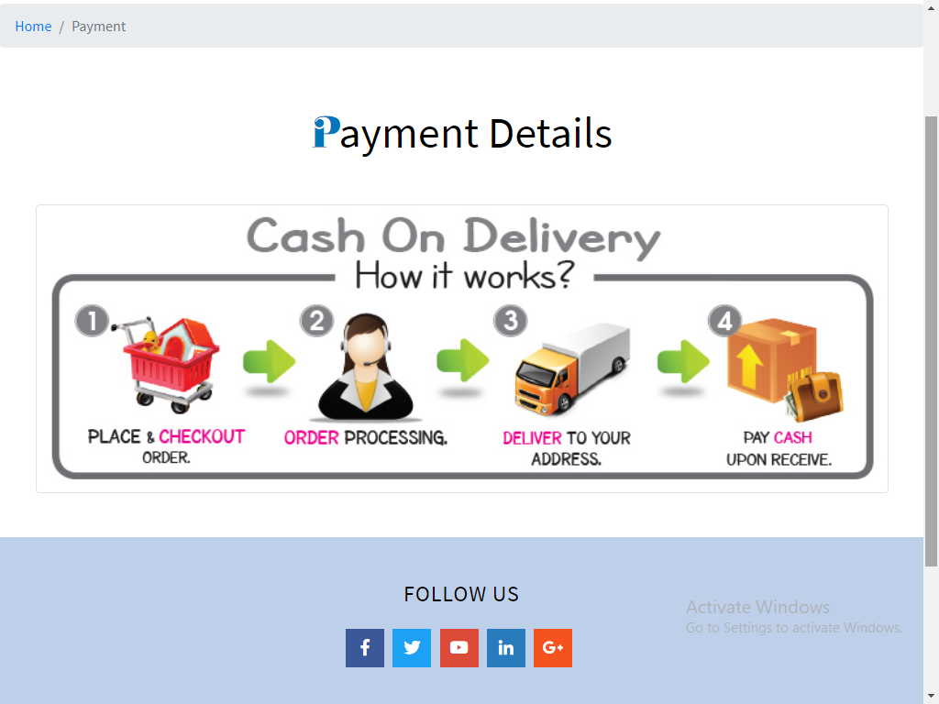

1. Contact Us

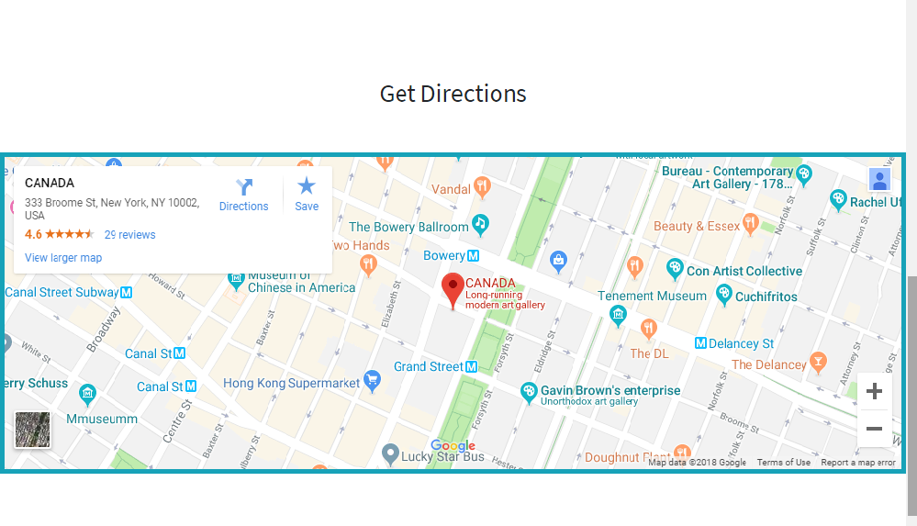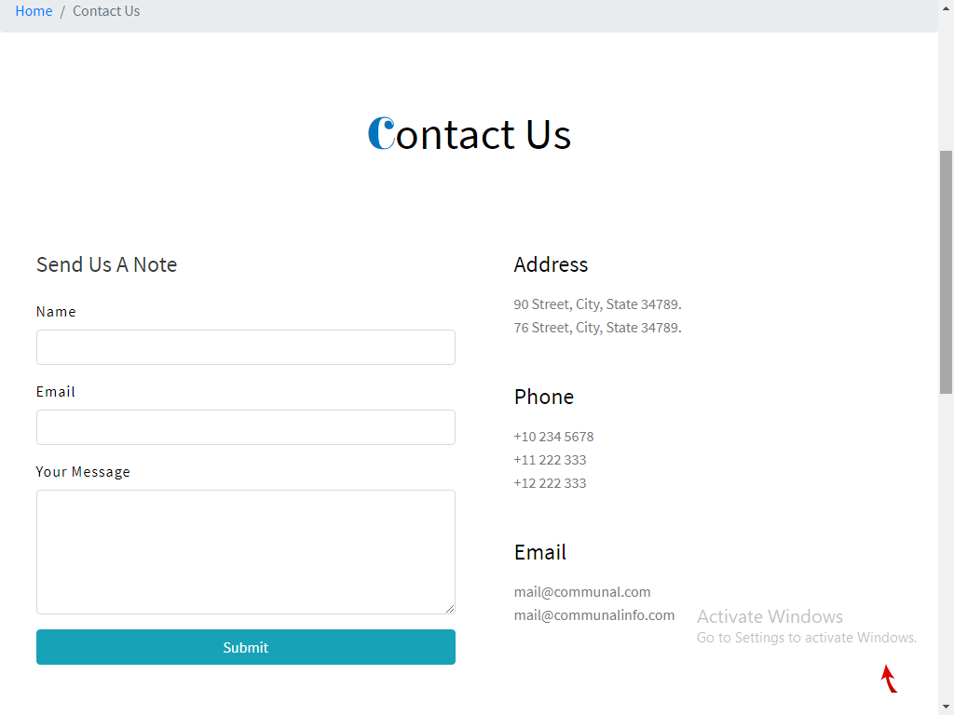

1. Faqs

